**Experiment 10 Date:** 03/04/2023

# Aim:

Familiarization of Linux Commands

# Course Outcome(CO4):

Write shell scripts required for system administration

# Procedure:

1. Shell script to add two number: vi filename.sh

Press ‘i’ to INSERT #!/bin/bash value=`expr 2 + 13`

echo "Total value : $value" Press ‘Esc’ to end INSERT

:wq!

chmod +x filename.sh

./filename.sh Output:

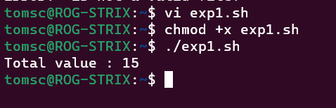

1. Write a shell script to initialize two numeric variables. Then perform addition operation on both values and store the result in the third variable.

vi filename.sh Press ‘i’ to INSERT #!/bin/bash num1=12

num2=48

sum=$(( $num1 + $num2 )) echo "Sum : $sum"

Press ‘Esc’ to end INSERT

:wq!

chmod +x filename.sh

./filename.sh Output: 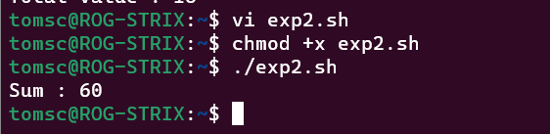

1. Shell script to read two numbers as command line parameters and perform the addition operation

vi filename.sh Press ‘i’ to INSERT #!/bin/bash sum=$(( $1 + $2 )) echo "Sum : $sum"

Press ‘Esc’ to end INSERT

:wq!

chmod +x filename.sh

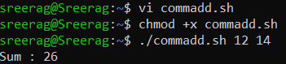./filename.sh num1 num2 Output:

1. Shell script which takes input from the user at run time and then calculate the sum of given number and store to a variable and show the result

vi filename.sh Press ‘i’ to INSERT #!/bin/bash

read -p "Enter the First number: " num1 read -p "Enter the Second number: " num2 sum=$(( $num1 + $num2 ))

echo "Sum : $sum"

Press ‘Esc’ to end INSERT

:wq!

chmod +x filename.sh

./filename.sh num1 num2 Output:

1. Shell script to demonstrate Arithmetic operators (addition, subtraction, multiplication, division, modulus, increment, decrement) by taking user input and store to another variable

vi filename.sh Press ‘i’ to INSERT

#!/bin/bash

read -p "Enter the First number: " num1 read -p "Enter the Second number: " num2 sum=$(( $num1 + $num2 ))

prd=$(( $num1 * $num2 )) diff=$(( $num1 - $num2 )) quo=$(( $num1 / $num2 )) rem=$(( $num1 % $num2 )) echo "Sum : $sum"

echo "Product : $prd" echo "Difference : $diff" echo "Quotient : $quo" echo "Remainder : $rem" if [ $num1 == $num2 ] then

echo "$num1 is equal to $num2"

fi

if [ $num1 != $num2 ] then

echo "$num1 is not equal to $num2"

fi

(( ++num1 ))

echo "Increment operator on first number: $num1" (( --num2 ))

echo "Decrement operator on second number: $num2" Press ‘Esc’ to end INSERT

:wq!

chmod +x filename.sh

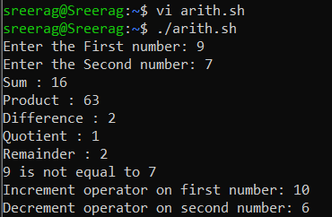./filename.sh Output:

# Result:

Output displayed successfully and CO4 was obtained.

**Experiment 11 Date:** 04/04/2023

# Aim:

Familiarization of Linux Commands

# Course Outcome(CO4):

Write shell scripts required for system administration

# Procedure:

1. Shell script to demonstrate Relational operators (equal to, not equal to, greater than, less than, greater than or equal to, less than or equal to) by taking user input

vi filename.sh Press ‘i’ to INSERT #!/bin/bash

read -p "Enter the First number: " num1 read -p "Enter the Second number: " num2 if(( $num1 == $num2 ))

then

else fi

echo "== : $num1 is equal to $num2" echo "== : $num1 is not equal to $num2"

if(( $num1 != $num2 )) then

else fi

echo "!= : $num1 is not equal to $num2" echo "!= : $num1 is equal to $num2"

if(( $num1 > $num2 )) then

else fi

echo "> : $num1 is greater than $num2" echo "> : $num1 is not greater than $num1"

if(( $num1 < $num2 )) then

else fi

echo "< : $num1 is less than $num2" echo "< : $num1 is not less than $num2"

if(( $num1 >= $num2 )) then

else fi

echo ">= : $num1 is greater than or equal to $num2" echo ">= : $num1 is not greater than or equal to $num2"

if(( $num1 <= $num2 )) then

else fi

echo "<= : $num1 is less than or equal to $num2" echo "<= : $num1 is not less than or equal to $num2"

Press ‘Esc’ to end INSERT

:wq!

chmod +x filename.sh

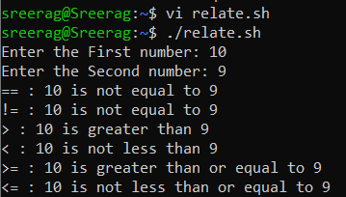./filename.sh Output:

1. Shell script to demonstrate Relational operators (equal to, not equal to, greater than, less than, greater than or equal to, less than or equal to)

vi filename.sh Press ‘i’ to INSERT #!/bin/bash num1=54

num2=20

if [ $num1 -eq $num2 ] then

else fi

echo "-eq : $num1 is equal to $num2" echo "-eq: $num1 is not equal to $num2"

if [ $num1 -ne $num2 ] then

else fi

echo "-ne: $num1 is not equal to $num2" echo "-ne: $num1 is equal to $num2"

if [ $num1 -gt $num2 ] then

else fi

echo "-gt: $num1 is greater than $num2" echo "-gt: $num1 is not greater than $num1"

if [ $num1 -lt $num2 ] then

else fi

echo "-lt: $num1 is less than $num2" echo "-lt: $num1 is not less than $num2"

if [ $num1 -ge $num2 ] then

else fi

echo "-ge: $num1 is greater than or equal to $num2" echo "-ge: $num1 is not greater than or equal to $num2"

if [ $num1 -le $num2 ] then

else fi

echo "-le: $num1 is less than or equal to $num2" echo "-le: $num1 is not less than or equal to $num2"

Press ‘Esc’ to end INSERT

:wq!

chmod +x filename.sh

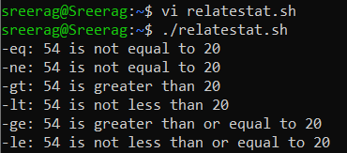./filename.sh Output:

1. Shell script to demonstrate Logical operators (AND, OR, NOT) by taking user input

vi filename.sh Press ‘i’ to INSERT #!/bin/bash

read -p "Enter the First Boolean: " b1 read -p "Enter the Second Boolean: " b2 if(($b1 == "true" & $b2 == "true" )) then

else fi

echo Both are true echo Both are not true

if(($b1 == "true" || $b2 == "true" )) then

else fi

echo Atleast one of them is true echo None of them are true

if(( ! $b1 == "true" )) then

else fi

echo "b1" was initially false echo "b1" was initially true

Press ‘Esc’ to end INSERT

:wq!

chmod +x filename.sh

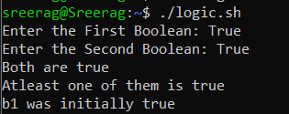./filename.sh Output:

1. Write a shell script to check if a number is even or odd. vi filename.sh

Press ‘i’ to INSERT #!/bin/bash

read -p "Enter a Number: " num1 if(( $num1 == 0 ))

then

echo "$num1 is neither odd nor even number"

elif(( $num1 % 2 == 0 )) then

else fi

echo "$num1 is an even number" echo "$num1 is a odd number"

Press ‘Esc’ to end INSERT

:wq!

chmod +x filename.sh

./filename.sh Output: 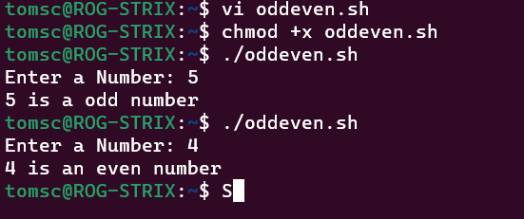

1. Write a shell script to check whether a number is positive or negative vi filename.sh

Press ‘i’ to INSERT #!/bin/bash

read -p "Enter a Number: " num1 if(( $num1 > 0 ))

then

echo "$num1 is a positive number" elif(( $num1 < 0 ))

then

else fi

echo "$num1 is a negative number" echo "$num1 is zero"

Press ‘Esc’ to end INSERT

:wq!

chmod +x filename.sh

./filename.sh Output:

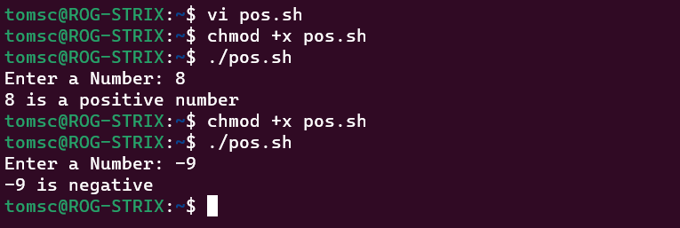

1. Write a shell script to find the greatest of two numbers vi filename.sh

Press ‘i’ to INSERT

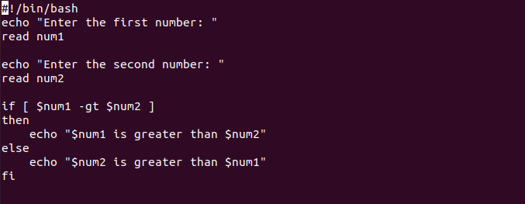

Press ‘Esc’ to end INSERT

:wq!

chmod +x filename.sh

./filename.sh Output: 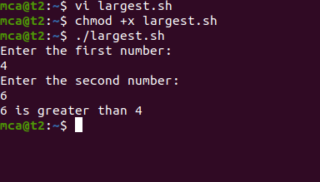

1. Write a shell script to find the greatest of three numbers vi filename.sh

Press ‘i’ to INSERT #!/bin/bash

read -p "Enter the first number: " num1 read -p "Enter the second number: " num2

read -p "Enter the third number: " num3 if(( $num1 > $num2 & $num1 > $num3 )) then

echo "$num1 is the greatest of the three" elif(( $num2 > $num3 ))

then

else fi

echo "$num2 is the greatest of the three" echo "$num3 is the greatest of the three"

Press ‘Esc’ to end INSERT

:wq!

chmod +x filename.sh

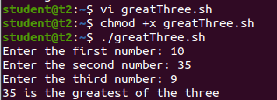./filename.sh Output:

# Result:

Output displayed successfully and CO4 was obtained.

**Experiment 12 Date:** 11/04/2023

# Aim:

Familiarization of Linux Commands

# Course Outcome(CO4):

Write shell scripts required for system administration

# Procedure:

1. Shell script to demonstrate String operators (Equal, Not Equals, Size is zero, Size is non-zero, Empty string) by taking user input

vi filename.sh Press ‘i’ to INSERT #!/bin/bash

read -p "Enter the first string: " str1 read -p "Enter the second string: " str2 if(( $str1=$str2 ))

then

else fi

echo "Both strings are equal" echo "Both strings are not equal"

if(( $str1!=$str2 )) then

else fi

echo "Both strings are not equal" echo "Both strings are equal"

if(( -z$str1 )) then

else fi

echo "String size is zero" echo "String size is non-zero"

if(( -n$str1 )) then

else fi

echo "String size is non-zero" echo "String size is zero"

if(( $str1 )) then

else fi

echo "String is Empty" echo "String is not Empty"

Press ‘Esc’ to end INSERT

:wq!

chmod +x filename.sh

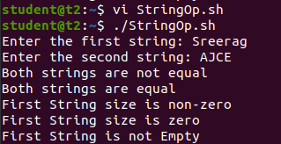./filename.sh Output:

1. Shell script to demonstrate Bitwise operators (AND, OR, XOR, Complement, Right Shift, Left Shift) by taking user input

vi filename.sh Press ‘i’ to INSERT #!/bin/bash

read -p "Enter the first value: " bin1 read -p "Enter the second value: " bin2 result=$(( $bin1&$bin2 ))

echo "Bitwise AND: $result" result=$(( $bin1|$bin2 )) echo "Bitwise OR: $result" result=$(( $bin1^$bin2 )) echo "Bitwise XOR: $result" result=$(( ~$bin1 ))

echo "Bitwise COMPLEMENT of First Value: $result" result=$(( $bin1<<2 ))

echo "Bitwise RIGHT SHIFT(4) of First Value: $result" result=$(( $bin1>>2 ))

echo "Bitwise LEFT SHIFT(4) of Second Value: $result" Press ‘Esc’ to end INSERT

:wq!

chmod +x filename.sh

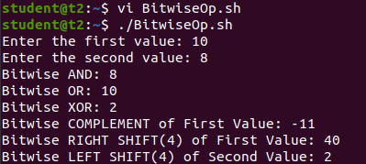./filename.sh Output:

1. Shell script to demonstrate File Test operators (Exist(e), Size(s), Read Permission(r),

Execute Permission(x), Write Permission(w)) by taking user input

* 1. vi filename.sh
  2. Press ‘i’ to INSERT
  3. #!/bin/bash
  4. read -p "Enter file name: " f1
  5. if [ -e $f1 ]
  6. then
  7. echo "$f1 exist"
  8. else
  9. echo "$f1 does not exist"
  10. fi
  11. if [ -s $f1 ]
  12. then
  13. echo "$f1 is not empty"
  14. else
  15. echo "$f1 is empty"
  16. fi
  17. if [ -r $f1 ]
  18. then
  19. echo "$f1 has read permission"
  20. else
  21. echo "$f1 does not have read permission"
  22. fi
  23. if [ -x $f1 ]
  24. then
  25. echo "$f1 has execute permission"
  26. else

aa. echo "$f1 does not have execute permission"

bb. fi

cc. if [ -w $f1 ] dd. then

ee. echo "$f1 has write permission" ff. else

gg. echo "$f1 does not have write permission" hh. fi

ii. Press ‘Esc’ to end INSERT jj. :wq!

kk. chmod +x filename.sh ll. ./filename.sh

mm. Output:

nn. 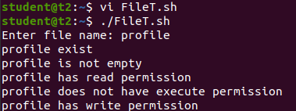

1. Shell Script to check if two numbers are equal using if statement
   1. vi filename.sh
   2. Press ‘i’ to INSERT
   3. #!/bin/bash
   4. read -p "Enter the first number: " num1
   5. read -p "Enter the second number: " num2
   6. if(( $num1==$num2 ))
   7. then
   8. echo "Both numbers are equal"
   9. fi
   10. if(( $num1!=$num2 ))
   11. then
   12. echo "Both numbers are not equal"
   13. fi
   14. Press ‘Esc’ to end INSERT
   15. :wq!
   16. chmod +x filename.sh
   17. ./filename.sh
   18. Output:

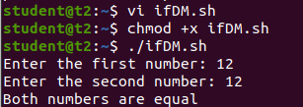s.

1. Shell Script to check the range of a number if numbers using else if ladder
   1. vi filename.sh
   2. Press ‘i’ to INSERT
   3. #!/bin/bash
   4. read -p "Enter the number(b/w 0-50): " num1

e. if(( $num1>=0&&$num1<=10 ))

1. then
2. echo "$num1 is between 0 and 10"

h. elif(( $num1>=11&&$num1<=20 ))

i. then

j. echo "$num1 is between 10 and 20"

k. elif(( $num1>=21&&$num1<=30 ))

1. then
2. echo "$num1 is between 20 and 30"

n. elif(( $num1>=31&&$num1<=40 ))

1. then
2. echo "$num1 is between 30 and 40"

q. elif(( $num1>=41&&$num1<=50 ))

1. then
2. echo "$num1 is between 40 and 50"
3. fi
4. Press ‘Esc’ to end INSERT
5. :wq!
6. chmod +x filename.sh
7. ./filename.sh
8. Output:

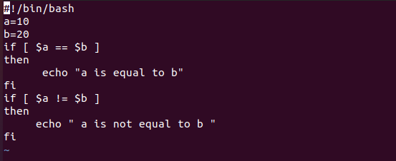

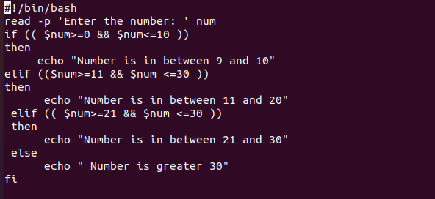

1. Shell Script to display the grade of a student by accepting his mark.